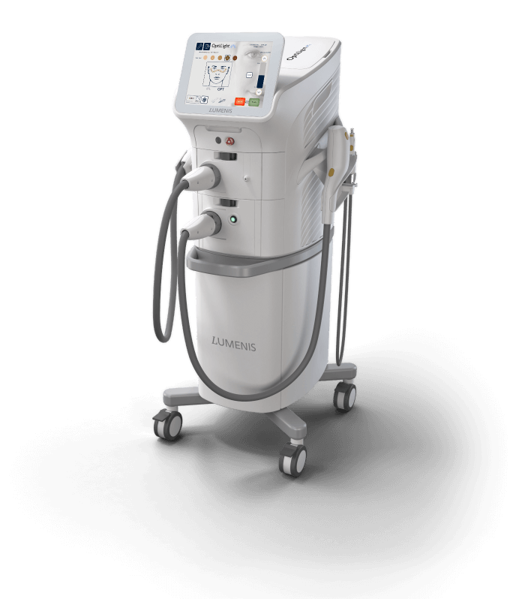
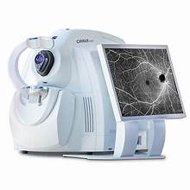

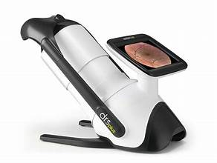
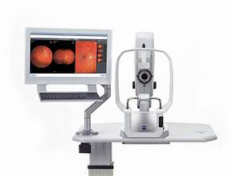
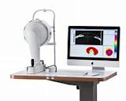

www.avcvictoria.com
2710 E. Airline Rd Victoria, TX 77901
361-485-9421
We are looking for an associate to join our growing private practice in South Texas. Our office was recently remodeled in 2023. We see a mix of medical and routine exams. We have six exam lanes, a full lab, modern technology that includes an OCT, Retinal Cameras, Pentacam, Myopia Master, Firefly Slit Lamp Camera and an IPL. Our Mission is to give our patients the best care and experience as possible.
Competitive Salary. Benefits with bonus structure. New graduates are welcome.
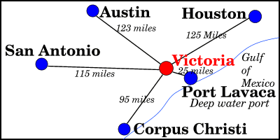
Victoria is located 30 miles inland from the Gulf of Mexico. It is a regional hub for a seven-county area known as the "Golden Crescent" and serves a retail trade area of over 250,000 people. Victoria is known as "The Crossroads" because of its location within a two-hour drive of Corpus Christi, Houston, San Antonio, and Austin.
The population was 65,534 as of the 2020 census. The three counties of the Victoria Metropolitan Statistical Area had a population of 111,163 as of the 2000 census.^{[3]}
Please contact Valerie Baker, OD at 361-212-3420 for more information.

