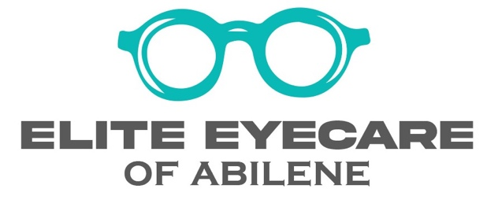

JOB DESCRIPTION:
Are you looking for the opportunity of a lifetime as an Optometrist to join a locally owned cutting-edge private practice in Texas?! Are you capable of delivering a world class eyecare experience? Do you enjoy making personal connections with patients and truly making a difference in their lives? Then Elite Eyecare of Abilene might just be the place for you!
Get to know Elite Eyecare further:
- Because of our growth, we are currently looking to add an ambitious and personable Optometrist to our team.
- Our full scope practice handles ALL ASPECTS of vision care including medical eyecare, refractive care, contact lenses, and sports vision.
- Our patients expect their Optometrist to deliver a thorough eye exam, be professional, confident in their abilities, and communicate effectively with patients.
- Must have a positive attitude and a passion for eyewear, and good sense of humor wouldn’t hurt either!
- We strive to WOW our patients and make their trip to the Optometrist fun and enjoyable. We go above and beyond your average optometry office.
- So, if you are just looking for a job, a place to clock in and clock out, not committed to being the best, then you most likely won’t fit in here.
Our optical is focused on independent frame lines. We offer the latest eyewear styles and fashion trends to our patients. We have an incredible team who are highly trained and able to fully support our doctors’ medical and optical treatment plans.

We are always investing in new ways to better care for our patients. Our practice is fully equipped with Retinal Imaging, OCT, Virtual Visual Field, iCare Tonometer, Anterior Segment Cameras, EHR, Senaptec Sensory Station, Santinelli in-house edging system and more.
As an employed OD of Elite Eyecare of Abilene, you’ll enjoy a rich benefits package which includes:
- Competitive base salary with eligibility for quarterly production bonus
- Medical and Dental Insurance
- Paid vacation
- 401K company match
- Malpractice insurance
- Paid state licensing fees (Texas)
- Paid continuing education expense

We believe it is important to have a work life balance, therefore we are closed on weekends and holidays. We allow our doctors to flourish in their own areas of interest. Whatever your interest is, Elite Eyecare will help support you and your career goals.
If you haven’t yet found the environment and people that bring out the best in you, and you want to be a part of something big, something you can be proud of, then you’re the type of kindred spirit were searching for. Feel free to look at our Google reviews to see what our patients have to say about us and get insight as to who we are.
If you’re an Optometrist who fits the description, then you better act quickly! Send your CV and cover letter to Dr. Russell Liles at drliles2020@outlook.com.
The Abilene community is filled with wonderful people who are very supportive of local business. We are excited to be renovating our new state-of-the-art facility, where we plan to move in and add an associate doctor by the summer of 2023.
*All inquiries are strictly confidential

